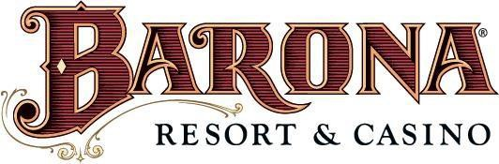

Injury and Illness Prevention Plan

(IIPP)

Table of Contents
Policy Overview 4
Our Goals 4
Responsibility 5
IIPP Program Administrator 5
Management 5
Supervisors 5
Staff Members 5
Reporting Work-related Injuries and Illness 6
Workers’ Injury Benefits 6
Identification and correction of Workplace Hazards 7
Scheduled Safety Inspections 7
Safety Compliance Committee 7
Compliance 7
Communication with Staff Members 8
Training 9
Material Safety Data Sheets (SDS) 10
Advisory Signs 10
Warning Labels 11
New Materials & Equipment 11
Equipment Operating Manuals 11
Occupational Health 11
Safe Lifting Techniques 12
Safe Handling Zones 12
Stretching Exercises 12
Code of Safe Practices 13
General Safety 13
Fire Safety 15
Evacuation 15
Biological Hazards 15
Workplace Hazard Evaluation and Abatement 15
Assessment of Hazards 15
Systems for Identifying Unsafe Conditions and Practices 16
Accident Investigation 16
Injury and Illness Investigation 16
Abatement of Hazards 17
Safety and Health Compliance Process 18

Policy Overview

It is the policy of the Barona Resort & Casino that every staff member is entitled to work under the safest conditions possible. To this end, every reasonable effort will be made to promote accident prevention, fire protection, and health preservation.

It is our belief that accidents which injure people, damage machinery and property, and destroy materials cause needless personal suffering, inconvenience, loss of assets, and other serious problems. We believe that practically all accidents can be prevented by taking good sense precautions.

Barona Resort & Casino will endeavor to maintain a safe and healthful work place. Barona Resort & Casino will provide safe working equipment, proper training, necessary personal protection, an emergency response plan, and, in the case of injury, provide first aid and medical services, as needed.

Each manager will be responsible for the overall effectiveness of the Barona Resort & Casino safety program. It is the responsibility of every staff member of the Barona Resort & Casino to participate in this program and we encourage both management and other staff members to participate in the various department safety programs to determine the overall direction and analysis of Barona Resort & Casino safety program operations and the communication of pertinent information to all departments.

You, as a staff member, have a need and the right to know what, if any, hazardous materials you may be exposed to when working. You also need to know what protective measures are available, to prevent adverse effects from occurring. Material safety data sheets (SDS), staff member training, product labels, and other forms of warning provide this information. Please check with your department on specific hazards and training. The belief that accidents are unavoidable is incorrect. If we all work together and stay vigilant, a healthy attitude toward accident prevention and improved safety on the job can be achieved.

Our Goals

To achieve these goals, the Barona Resort & Casino has adopted an Injury and Illness Prevention Program (IIPP). This program is everyone’s responsibility. We must work together to identify and eliminate conditions and practices that reduce the benefits of a safe and healthful work environment.
Our goal is to have zero accidents or injuries. It is also our expectation that the IIPP will benefit not only the Barona Resort & Casino, but also our players, vendors, contractors, and visitors by providing a safe and healthy environment. The IIPP shall incorporate and reference all existing Barona policies relevant to health, safety, and security procedures:
- To establish and maintain a safe environment for everyone.
- To eliminate hazards.
- To practice accident prevention.
- To promote and recognize safety consciousness and responsibility.
- To involve everyone in safety planning and prevention.
- To improve channels of communication.

Responsibility

All staff members are expected to work conscientiously to implement and maintain the IIPP. The Security Department has the authority and responsibility for implementing the provisions of this program. Any questions regarding the program should be directed to the Program Administrator. The Program Administrator will review and update the IIPP annually or as needed. The Program Administrator can be reached at extension 3616.

IIPP Program Administrator

The Program Administrator is responsible for full compliance of the IIPP, which includes, but is not limited to:
- Developing a Code of Safe Practices.
- Conducting safety and health inspections.
- Following up to ensure that necessary corrective action has been completed.
- Reviewing injury and illness trends.

Management

Each manager and supervisor is responsible for fostering a positive attitude towards safety in both themselves and those they supervise. Managers and supervisors must ensure they are familiar with all hazards associated with their specific operations. All work performed in their department must be done with due regard for the safety and health of all staff members.

Supervisors

It is the responsibility of supervisors to ensure that staff members are familiar with and abide by all Barona Resort & Casino safety policies and procedures. They are expected to do everything within their control to provide a safe work environment. Supervisors are responsible for:
- Keeping abreast of safety and health regulations affecting the operation they supervise.
- Ensuring that each subordinate knowledgeable and able to complete each assigned task safely.
- Conducting on-the-job training of those they supervise.
- Making sure equipment and machines are in safe operating condition.
- Ensuring team members follow safe-work practices and health regulations.
- Ensuring that staff members under their direction wear required personal protective equipment (PPE).
- Correcting unsafe and unhealthful conditions, within their power.
- Investigating accidents to discover cause(s) and identifying corrective action to prevent future occurrences.
- Conducting periodic inspection of their work areas according to the appropriate checklist.

Staff Members

All staff members are responsible for working safely, following all policies and procedures, and maintaining a safe and healthful work environment.
In the event that you are injured on the job, you will be entitled to benefits under a program similar to the California Workers’ Compensation system, per 10.4 of the Tribal and State Compact. As your employer, it is mandatory the Barona Resort and Casino provide these benefits to all staff members, regardless of Tribal affiliation. Barona is insured and will see that you receive all benefits to which you are entitled under the law. However, it is the duty of each staff member to notify their supervisor promptly if they are injured on the job.

Reporting Work-related Injuries and Illness

All job-related injuries and illnesses must be reported, regardless of severity. It must first be determined if the injury or illness was the result of some aspect of the work environment. Some injuries from voluntary, off-duty, recreational, social or athletic activities (eg. an unsponsored company bowling team) may not be covered. Check with the Human Resources Department if you have questions.

Workers’ Injury Benefits

All medical treatment will be provided to any staff member injured by a work-related injury or illness. When a work-related injury or illness occurs:
- Report all injuries immediately to both your supervisor and Security.
- Provide or seek first aid.
- Seek professional medical care, if necessary.
- Request a claim form if it’s more than a simple first-aid injury.
  - Any delay in reporting an injury may cause a delay or denial of benefits.
- Talk to your Human Resources Specialist if you have questions about the Workers’ Compensation program.
Costs are paid directly by the claims administrator, so the injured staff member should never see a bill, however, the injured staff member must obtain authorization for an non-emergency medical procedures, prior to treatment. The claims administrator will arrange medical treatment, often by a specialist for the particular injury. This benefit is provided to all staff members. If a staff member is temporarily disabled by a covered job injury or illness, he/she will be compensated at two-thirds of their normal pay. This compensation is tax-free and will continue until the injured staff member is released to return to work by the treating physician. The staff member will not be compensated for the first three days of temporary disability. Payments will only be made for the first three days if the staff member is hospitalized as an inpatient, or otherwise unable to work, for more than 14 days.

All worker’s compensation claims are administered by:
Tribal First
P.O. Box 609015
San Diego, CA 92160
(800) 552-8921

Please Note: All claims for workers’ compensation benefits are submitted under penalty of perjury of the laws of the United States and the Tribe. Any person who knowingly files, or assists in the filing, a false claim risks prosecution.

Identification and correction of Workplace Hazards

Management is responsible for ensuring that Barona Resort & Casino safety and health policies and procedures are properly communicated and understood by all staff members and to identify any training needs. Staff members who are unaware of correct safety and health procedures will be trained or retrained (see Training section). Updated safety training will be provided to staff members as needed whenever new equipment, materials or procedures are introduced into the workplace.

Scheduled Safety Inspections

Continuous and thorough safety inspections are conducted at least monthly. Each area on the property is inspected for any observable compliance issues by members of the Safety Compliance Committee. All identified hazards are noted and provided to the Program Administrator for dissemination to the Director of Security and the Director of Facilities, as well as others (as needed or required).
Imminent hazards are corrected immediately at the time of inspection, whenever possible. All other hazards will be properly corrected soon as possible. Managers and supervisors are expected to daily monitor their specific work areas for safety and health hazards.

Safety Compliance Committee

The Safety Compliance Committee, along with the department managers and supervisors, will work together to correct and track workplace hazards. The Safety Compliance Committee will receive and review reports of unsafe conditions and workplace inspection reports. Specifically, the Safety Compliance Committee will:
- Review the results of periodic, scheduled workplace inspection to identify any needed safety procedures or programs and to track specific corrective actions.
- Where appropriate, submit suggestions to department management for the prevention of future incidents.
- Review alleged hazardous conditions brought to the attention of any committee member, determine necessary corrective actions, and assign responsible parties and correction deadlines.
- When necessary, the Committee may conduct its own investigation of accidents and/or alleged hazards to assist in establishing corrective actions.
- Submit recommendations to assist department management in the evaluation of staff member’s safety suggestions.

Compliance

All staff members are responsible for following safe work practices, complying with all directives, policies and procedures, and assisting in maintaining a safe work environment. As part of a staff member’s regular performance discussion, compliance with safe work practices will be discussed. Staff members who deliberately fail to follow safe work practices and/or procedures or who violate Barona Resort & Casino safety rules or directives will be subject to disciplinary action, up to and including termination. Managers and supervisors are expected to enforce the rules fairly and uniformly.

Communication with Staff Members

Barona Resort & Casino recognizes that open, two-way communication between management and staff on health and safety is essential to an injury-free productive workplace. The following system of communication is designed to facilitate a continuous flow of safety and health information between management and staff in a form that is easily understood:
- The new-hire orientation will include review of the Company’s Code of Safe Practices and a discussion of the IIPP the staff member is expected to follow.
- Barona Resort & Casino will schedule departmental and staff meetings in which safety is freely and openly discussed.
  - Such meetings will be scheduled and announced to all staff members to encourage maximum participation.
- From time to time, Barona Resort & Casino will post and/or distribute warning signs/labels, written safety notifications, and other notifications.
  - Safety related memos and documents are to be read promptly. If any staff member has questions about the content, they should contact their supervisor or a Safety Compliance Committee member.
- Other methods of communication of pertinent health and safety information include electronic mail, text messages, phone calls, department meetings, Safety Compliance Committee, Pre-Shift Briefing or Barona Information Sheet.
- All staff members are to inform their supervisor, manager, Security Department, Safety Compliance Committee, and/or the Human Resources Department of any matter they perceive to be a potential or existing workplace hazard. Staff members are also encouraged to make workplace safety and safety training suggestions.
  - If a staff member so wishes, he/she may make such notifications and suggestions anonymously by leaving a message on the Safety Hotline (ext. 3605) or by submitting a “Staff Member Report of Unsafe Condition, Hazard, or Procedure” form to the Human Resources drop box.
- In no way shall a staff member be retaliated against for reporting hazards or potential hazards, or for making suggestions related to safety.
- All suggestions will be reviewed by the Program Administrator, who will initiate an investigation of each report in accordance with company procedures for hazard control.
- Any directives issued as a result of the investigation shall be distributed to all staff members affected by the hazard and/or shall be posted in the appropriate areas.

Be sure you understand the safe way to perform any assigned task. When in doubt, ask your supervisor. Report all broken or defective equipment and all unsafe practices to your supervisor immediately.

Additionally, staff members can fill out a “Staff Member Report of Unsafe Condition or Hazard” form, which is available at the Human Resources Office. You can leave your contact information at the bottom of the form if you would like an update on your report, or you may turn them in anonymously in the drop boxes located outside the Human Resources office. These reports are regularly reviewed by the Barona Resort and Casino Safety Committee, who will follow up on the issue and ensure it is being handled correctly. You can also leave a message on the safety hotline at ext. 3605.

Training

Training is essential to maximizing the skill and knowledge of all staff members. The Barona Resort & Casino has a duty to include safety as an integral part of staff member training. Staff members need to work safely, as well as productively and efficiently.
Supervisors are the essential link in ensuring the proper outcome.

Supervisors must know how to perform designated jobs and be aware of all safety and health hazards facing staff members under their immediate supervision. Supervisors must provide training regarding general work place safety as well as safety and health issues specific to each job.
With this in mind, training will be conducted with the following considerations:
- Department managers will determine training topics.
- These include safety awareness, accident investigation, hazard communication, preventing incidental and ergonomic injuries, proper use of personal protective equipment, and chemical spill reporting procedures.
- Supervisors who recognize a personal need for training are encouraged to submit a direct request for training in any area in which they feel deficient.

All staff members will be trained on the content of the IIPP during New Staff Orientation. Training will also be provided regarding unsafe condition reporting, how to contact the Safety Compliance Committee, and where to obtain information regarding workplace safety and health issues. Staff members must also be trained in general workplace safety and safety issues particular to their assignments for issues not covered in other training sessions. The Barona Resort & Casino recognizes that ongoing safety and health training is needed when:
- staff members are given job assignments for which they have not previously received training.
  - If the position is supervisory, such training shall include familiarization with hazards and risks faced by staff members under their direction.
- new substances, processes, procedures, or equipment are introduced to the work environment.
- the supervisor, manager, department head, or Safety Compliance Committee becomes aware of a previously unrecognized hazard.
- periodically for all staff members.
  - This includes all refresher safety training involving general workplace safety, job-specific hazards, hazardous materials, and emergency response as applicable.

In addition to the above, a copy of the IIPP will be given to each staff member, which includes:
- Methods for communicating with staff members on safety matters.
- Methods for named and anonymous reporting of health and safety concerns.
- Procedures for identifying workplace hazards, including periodic inspections.
- Procedures for correcting unsafe or unhealthy conditions, work practices, and work procedures.
- Procedures for investigating injuries and illnesses.
- Methods for ensuring that staff members comply with the program.

Material Safety Data Sheets (SDS)

Material Safety Data Sheets (SDS) provide information regarding the potential hazards of products or chemicals. They are a detailed informational bulletin, prepared by the manufacturers of products containing caustic chemicals. They describe the physical and chemical properties, physical and health hazards, routes of exposure, precautions for safe handling and use, emergency and first-aid procedures, as well as control measures. Information on an SDS aids in the selection of safe products and helps employers and employees to effectively mitigate both daily exposure risks and emergency situations.

A physical copy of all SDS for chemicals used in specific areas and/or departments will be mounted in a dedicated bracket, case, or shelf located in the same area and/or department, and must be easily reachable and kept in plain sight at all times. Additionally, a computer database will be maintained by the Safety Compliance Committee and will be available through an online service by a link on the iBarona intranet service.

Advisory Signs

Advisory signs are used extensively throughout the property. These signs alert staff members to potential hazards. Staff members should constantly be aware of the signs and associated dangers.
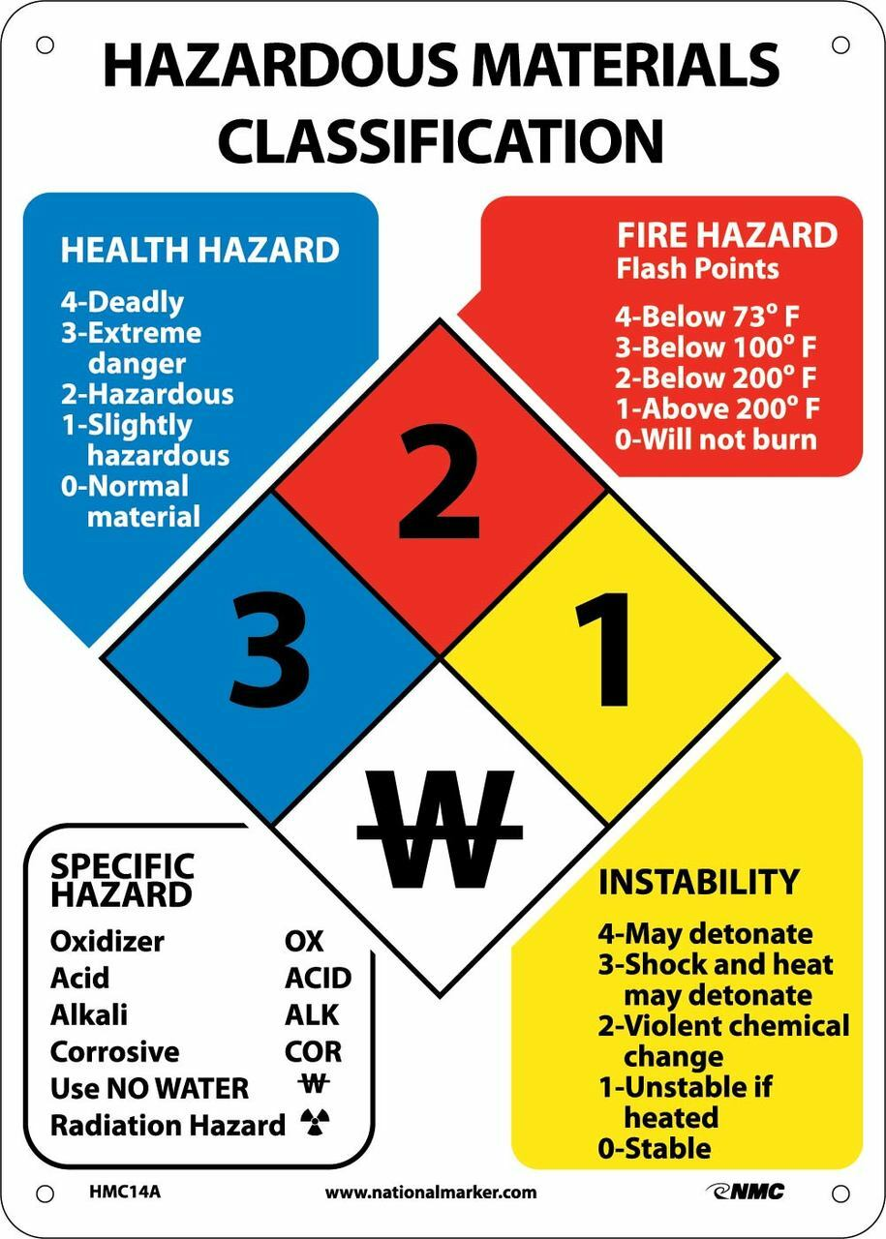

Warning Labels

All products used on this property that contain caustic chemicals shall be clearly labeled on the outside of the container. If the contents of the container have been relocated to another container, that container must also have proper labeling. It is important that each staff member understands the information of the label.
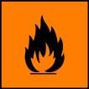 Flammable 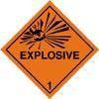Explosive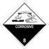Corrosive 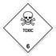Toxic

New Materials & Equipment

The responsible manager will arrange for inspection and investigation of any new substance or equipment introduced into the facility to ensure it does not present a potential occupational safety hazard. When a new product is introduced into work areas, managers must provide a copy of the product’s SDS to the Safety Compliance Committee. Additionally, the managers and supervisors must ensure all staff members affected by the use of the product are informed of the information contained in the SDS for that product.

Equipment Operating Manuals

All equipment is to be operated in accordance with the manufacturer’s instructions, as specified in the equipment’s operating manual. Copies of operating manuals will be kept with or near each piece of equipment in the department. Staff members who are unfamiliar with the operation of a piece of equipment and its potential hazards must read the operating manual and receive training from an experienced operator or supervisor before using the equipment. No staff member is to operate unfamiliar equipment without first following this procedure.

Occupational Health

All new staff members will be required to submit to a drug screen before they are allowed to start work. Random drug testing will be conducted at unannounced intervals. Drug testing will also be required when warranted due to objective symptoms or when involved in an incident causing injury or significant damage while operating a motor vehicle or heavy machinery.

The movements of a human body involved in lifting, pushing, or pulling objects can be characterized by the affects they have on the bones, muscles, and joints involved in performing the action. An object’s weight, balance, and size should always be considered before labor begins. Additionally, staff members shall not knowingly be permitted or required to work while their abilities are so impaired by fatigue, illness, or other causes that they may be unnecessarily exposed to risk of injury. Know when to ask for assistance or take a break from heavy labor, to prevent injury from overexertion or repeated stress.

Safe Lifting Techniques

When lifting objects, it’s not always how heavy the object is that can cause an injury, but rather the way in which the object is lifted. Here are some ways to use your body in the correct manner when lifting:
- Keep your head high, chin tucked in, and try to keep your back straight.
- Kneel down on one knee or squat.
- Bend with your knees and hips, not with your back.
- Get as close to the load as possible, don’t reach and lift.
- Plan ahead and test the load before lifting.
- Use both arms.
- Lift with your legs and buttocks, not your back.
- Lift slowly and smoothly, to avoid sudden a shift in the weight.
- Keep the weight as close to your body as possible when walking, and stand up straight.
- Avoid twisting while you are lifting or carrying.

Safe Handling Zones

The Red, Yellow, and Green Zones are an easy way for any staff member to determine whether they should lift or move an object individually or with another staff member (team lift).
- The Green Zone – Safest
  - The Green Zone involves the space right in front of the abdomen, with the arms in an ‘L’ position directly in front of or next to the waist.
- The Yellow Zone – Less Safe
  - The Yellow Zone involves the extension of the arms to an almost straight position in front of the abdomen.
  - The range of straight arms extends from shoulder height to waist height.
  - The yellow zone impacts the muscles in a small way and may result in soreness of the mid back and lower back.
  - If you have to carry a load in this manner, it may be in your best interest to ask someone for help, even if the load does not feel very heavy.
- The Red Zone – Danger Zone
  - The Red Zone involves the reaching of extended straight arms above shoulder height or below waist height.
  - The red zone has a large impact on the back muscles, which could result in strains or sprains.
  - Always ask for assistance when in this zone.

Stretching Exercises

Strong, flexible muscles and joints support the back’s three natural curves and enable good use of body mechanics in performing physical labor. Stretching exercises help to develop flexible muscles and are important in maintaining a healthy body. Stretching exercises should be performed slowly and smoothly, gradually obtaining a mild stretch. Don’t jerk or bounce into a stretch, as it may cause more harm than good. Consult a physician for proper stretching techniques, as these may vary by individual health needs and mobility restrictions.

Code of Safe Practices

According to leading studies conducted on insurance claims, approximately 98% of work-related injuries and accidents are preventable. While some accidents are unavoidable, approximately 88% of these accidents can be avoided simply by following safe practices and procedures. It is up to each and every staff member to take responsibility for their own safety and the safety of the other members of our Barona family. When performing tasks, pay attention to the task at hand. Do not take shortcuts. Follow all safety procedures and be aware of what is happening in the area.

General Safety

All staff members must adhere to this Code of Safe Practice and remain alert to any unsafe conditions or practices in each work area and throughout the Barona Resort & Casino property. Each department may have safety procedures specific to that department. When you begin working in your new position, be sure to ask your supervisor or departmental trainer. However, by following these simple rules, everyone can help to create and maintain a safe and welcoming environment:
- Do not wear loose fitting clothing or jewelry around machinery, and ensure you are always using proper personal protective equipment (PPE) when required.
  - Your supervisor and departmental trainer will inform you of the requirements for your department.
- Horseplay and practical jokes are not allowed at any time. Should an injury occur due to horseplay you may be denied Workers’ Compensation benefits.
- NEVER block emergency exits, fire extinguishers, aisles, stairways, and entrances. These areas are to be kept clean and free from obstructions of any kind at all times. Leaving brooms, mops, boxes, carts, or other objects where someone may fall over them is prohibited.
- Use chairs properly and safely.
  - Do not tilt back in a chair since this often results in overbalancing and a fall. Be sure your chair is behind you before you sit down.
- Report defective chairs immediately to your supervisor.
  - These can be extremely dangerous, especially for the unsuspecting victim.
- Use an approved step stool or ladder when you need to climb or reach a high level.
  - Never use chairs, open drawers, boxes, or other fixtures/objects in place of a step stool or ladder.
  - These items are not designed for this purpose and will not be able to keep you from falling to the floor.
  - Immediately report and properly dispose of ladders with any defects.
- When using a stepladder, be sure the stepladder spreaders are open and the ladder is placed on level ground.
- Move the ladder to the area you need to access.
  - Do not reach and extend out to the side, which may cause the ladder to fall.
- Always keep one hand free to balance you while ascending, standing or descending the ladder.
- Always face the front of the ladder going up or coming down.
- There should only be one person on the step ladder at a time.
  - Too much weight can break or weaken the ladder.
- Never use the top step of a ladder.
- Do not over-reach.
  - Stretching to reach overhead objects may result in falls, strains, or pulling an item onto someone’s head.
- Keep file and desk drawers closed when not in use.
- Walk; do not run in passageways, workplaces or on stairs.
- Select and wear the appropriate shoes.
  - Slippers and sandals are unsafe and are not allowed at the Barona Resort and Casino.
  - Please wear suitable closed toe work shoes.
- Wear shoes with moderate heels.
  - These lessen fatigue as well as provide firmer footing.
  - Be cautious of leather heels, slack cuffs that are too long and untied shoe strings that can cause a fall.
- Watch your step.
  - Do not read while walking and do not carry bulky objects that obstruct your view.
- Wipe up wet spots promptly.
  - Carry beverages in covered containers or on trays to help prevent spills.
- Never leave a spill unattended.
  - If you encounter a spill of any kind, please stay with the spill and ask a fellow staff member to find something to clean the spill, or to contact Housekeeping or Security for assistance.
    - Even small spills can cause someone to slip and fall, resulting in serious injury.
- Keep floors clean.
  - Even something as small as a pencil or paper clip could cause someone to slip and fall.
- Keep wastebaskets, phone and extension cords out of walkways as they are serious tripping hazards.
- Do not congregate on stairs or landings or stand near doors at the head or foot of stairways.
- Do not go up and down stairs with your hands full.
  - When carrying materials, take your time and use the handrails.
  - Never let packages obstruct your vision.
- Remain alert when using stairs.
  - You may be risking a fall if you are talking, laughing and turning or pointing to others while going up or down stairs.
- Always use handrails on stairway and at entrances.
  - Take one step at a time when ascending or descending stairs.
  - Do not run on or jump down stairs.
- Observe all “No Smoking” signs and rules, for the protection of yourself and others.
- Drugs and alcohol are strictly prohibited. Failure to comply with this policy may result in immediate termination.

Fire Safety

Staff members are not expected to use fire extinguishers unless they have completed a Fire Extinguisher Training Class. Should you notice smoke or fire, notify your supervisor and Security immediately by contacting a Security Officer stationed in your area, calling Casino Dispatch on your radio, or calling Security directly at extension 5911.

Evacuation

During a serious emergency, your supervisor or Security personnel may give instructions to evacuate the area. Please follow your department’s evacuation plan and proceed immediately to the nearest designated staging area. Do not leave the property without being instructed to do so by Security. We can help save the lives of emergency responders by not having them look for staff members whom have already left.

Biological Hazards

In the event of blood or other bodily fluid spills, or contamination of any kind, never expose yourself to biohazardous substances. There are specific staff members in Security, Housekeeping, and the Emergency Medical Services (EMS) departments who are trained in the proper handling of biohazardous materials. Should your position require training in handling such hazards, your manager will notify Loss Prevention.

Workplace Hazard Evaluation and Abatement

Hazard control is at the heart of an effective IIPP. Barona Resort & Casino hazard control procedures are designed to identify hazards that exist or develop in the workplace, describe how to correct those hazards, and initiate steps to prevent their occurrence or recurrence.

Assessment of Hazards

Inspection of the workplace is the primary method used to identify unsafe conditions and practices. While we encourage all staff members to continuously identify and correct hazards and poor safety practices, certain situations require formal evaluation and documentation.
The Program Administrator and Safety Compliance Committee members will conduct inspections and investigations for the following reasons:
- Routine inspection in each work area.
  - The time and frequency of inspection will be determined by the Program Administrator, Director of Security, and/or General Manager (or designee), according to the type of work being performed in each area.
- When new substances, processes, procedures or equipment are introduced.
  - Each supervisor is responsible for promptly reporting to the Safety Compliance Committee whenever a new substance (such as chemical or solvent), new work procedure or technique, and/or new equipment are introduced which may pose a safety risk.
  - An evaluation of the potential hazard(s), training and/or other steps to be taken to provide abatement solutions for any potential hazard(s) should be addressed.

  - Based upon the information provided or acquired, the Program Administrator, or other member of the Safety Compliance Committee, will conduct an inspection and issue directives as necessary.
- When the Safety Compliance Committee becomes aware of a new or previously unrecognized hazard, either independently or by receipt of information from a staff member, including issues reported anonymously.
- When an occupational injury, occupational illness or “near-miss” accident occurs (see Accident Investigation section).

Systems for Identifying Unsafe Conditions and Practices

Methods used to identify unsafe conditions and practices include several different techniques, such as a review of pertinent safety orders, job safety analysis, self-inspection checklist, and reviews of accident statistics and information developed by an outside consultant.

The two formal methods of hazard identification are Job Hazard Analysis (JHA) and periodic safety inspections. A JHA can be completed by supervisors and the results can be used as training tools. Periodic safety inspection frequency will depend on the type of inspection to be completed. The following will be used as a guideline:
- Daily
  - High hazard or frequently changing operations or equipment (forklifts, vehicles).
- Weekly
  - Hazardous areas (flammable storage areas and hallways).
- Monthly
  - Player areas, back-of-house areas, miscellaneous storage facilities, fabrication areas, and parking structure and lots.

Accident Investigation

The purpose of an accident investigation is to determine the cause of the accident and prevent further occurrences. It is not intended to be used to place blame.
A thorough and properly conducted accident investigation is necessary to obtain the facts required to both analyze the accident and determine how similar accidents may be prevented in the future. The investigation will focus on causes and hazards.

Injury and Illness Investigation

After a workplace injury or illness has occurred, the supervisor of the involved staff member(s) is responsible for performing an investigation to determine and correct the cause(s) of the incident. This report should be completed within 24 hours of the occurrence. Specific procedures to be used to investigate workplace accidents and hazardous substance exposures include:
- Interviewing injured personnel and witnesses.
- Examining the injured staff member’s workstation for causative factors.
- Reviewing established policies and procedures to ensure they are adequate and followed correctly.
- Reviewing training records of affected staff members.
- Determining all primary and secondary contributing causes (equipment malfunction, maintenance issues, improper construction materials, chemical interactions, unauthorized activities, inclement weather, etc.).
- Taking corrective actions to prevent the accident/exposure from repeating.
- Documenting all findings and actions.

The supervisor’s findings and corrective actions should be documented on the “Supervisors Investigation Report”. The staff member involved should also document their version of events on the supplementary Staff Member Incident Report. If the supervisor is unable to determine the cause(s) and appropriate corrective actions, other resources should be utilized.

Abatement of Hazards

It is the intent of the Barona Resort & Casino Operations Committee to eliminate all hazards and unsafe work practices immediately. Though some corrective actions may require more time, priority will always be given to severe and imminent hazards.

During each inspection and investigation, the Program Administrator and Safety Compliance Committee shall evaluate the severity the hazards identified and determine whether it can be abated immediately. The Program Administrator, working with the Safety Compliance Committee, shall then suggest a priority of corrective actions.
A Hazard Checklist, Hazard Assessment Form, Safety Manifest, and/or internal e-mail chain will be used to document inspections/investigations, as appropriate.

The Hazard Checklist/Hazard Assessment forms completed during an inspection or investigation will be used to the describe measures taken to abate the hazard or correct the unsafe work practice. Actions to be taken may include, but are not limited to:
- Repairing or replacing defective equipment.
- Implementing safer procedures.
- Installing guards or modifying equipment.
- Staff member training.
- Posting or replacing warning notices.

All actions taken and the dates they are implemented shall be documented on the appropriate forms. While corrective actions are in progress, necessary precautions are to be taken to protect or remove staff members from exposure to the hazard. Staff members will not enter a high hazard area without prior specific approval of the Program Administrator (or above). Staff members who are involved in the correction of the imminent hazard shall be properly trained and provided with necessary safeguards.

Safety and Health Compliance Process

Disciplinary measures may be taken against staff members failing to follow the provisions of the IIPP. Disciplinary action is progressive and may involve four steps:
- Should a safety and health violation be noted, the supervisor is to informally discuss the behavior with the staff member, addressing the potentially dangerous results and outlining the correct procedure, followed by immediate re-training of the staff member to make sure they understand.
- A second violation may generate either a verbal warning or a written warning to the staff member, depending on the severity of the violation.
- A third violation may result in a written warning or staff member suspension.
- A fourth violation may lead to suspension pending investigation and/or possible termination.

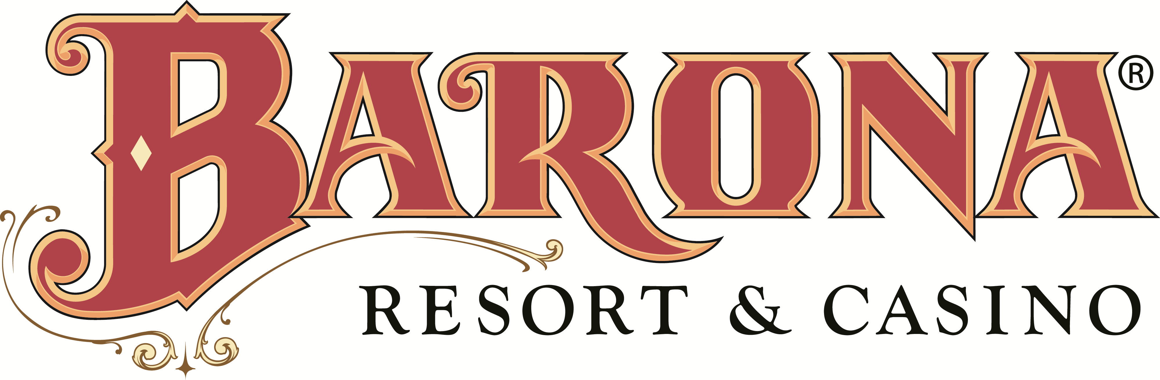

STAFF MEMBER REPORT OF
UNSAFE CONDITION, HAZARD OR PROCEDURE

DATE:

NAME: (Optional)

DEPARTMENT/AREA

DESCRIPTION OF CONDITION, HAZARD OR PROCEDURE

DATE AND TIME THE ISSUE WAS OBSERVED

DO YOU HAVE A RECOMMENDATION TO CORRECT THE ISSUE?

IF YOU WOULD LIKE TO BE CONTACTED FOLLOWING THE REVIEW OF THIS REPORT, HOW MAY WE CONTACT YOU?

REPORTE DE EMPLEADO DE
CONDICIONES PELIGROSAS

FECHA:

NOMBRE: (Opcional)

DEPARTAMENTO/ZONA

DESCRIPCION DE PROCEDIMIENTO O CONDICION PELIGROSA

FECHA Y TIEMPO QUE FUE OBSERVADO

¿TIENE UD. RECOMENDACION PARA CORREGIR EL ASUNTO?

¿SI QUIERE SER INFORMADO DESPUES DE QUE SE EXAMINE ESTE REPORTE COMO PODEMOS COMUNICARNOS CON UD.?

Illness and Injury Prevention Plan
Staff member Acknowledgment of Review

TO ALL STAFF MEMBERS:

The Injury and Illness Prevention Program is to be reviewed with all staff members upon implementation of the program or when newly hired. This program has been developed as guide for safe work practices and is provided for your safety.

Although this program is reviewed with you, you are responsible for reading and complying with this code. Please ask if you have any doubts or questions on how to perform your job safely.

I agree to conform to all practices, safety rules, and regulations relating to safe work performance.

Each staff member is required to acknowledge review of this program. Please sign and date below and return only this page to Human Resources Office.

I have read and understand the Injury and Illness Prevention Program, and agree to comply with the Code of safe practices set forth in it.
Reviewed by:
(Print)
Staff member:
(Print)
Title:
Title:
Signature:
Signature:
Date:
Date:

